Curtis Ruta
0959468
Section: Tuesday, 11:30am
AGR1110
Tuesday November 29th, 2016
Exportable Dairy Vitamin Supplement to Nepal

Part 1 – Product Information
Product Description and Health Benefits
A very suitable product to send to Nepal is Multimin 90. Multimin 90 is a vitamin and mineral supplement for all cattle, dairy and beef that insures growth and overall health by boosting the immune system through an injectable needle of trace vitamins and minerals. Multimin 90 is a vitamin and mineral supplement of manganese, copper, selenium, and zinc. This vitamin is easily available in a needle form, which has added benefits to the vitamin (The Cattleman, 2010). One millilitre of Multimin 90 contains 10 milligrams of manganese, 15 milligrams of copper, 60 milligrams of zinc, and 5 milligrams of selenium (Pogge, Ritcher, Drewnoski, & Hansen, 2012). Each of those trace vitamins and minerals has a different effect on cattle then the other. To start, manganese gives the animal antioxidant protection for sperm cryopreservation, which opens a new window for Nepal farmers (Cheema, Bansal, & Bilaspuri, 2009). Nepal cattle farmers are looking to become more advanced, they are looking for ways to make the industry better in Nepal, therefore adding additional manganese supplement to the cattle would prolong the survival time and quality of frozen semen. Therefore, the artificial insemination industry in Nepal may climb with a more reliable source of cattle sperm. The second vitamin/ mineral within Multimin 90 is copper, when deficient in copper there is a depletion of cytochrome oxidase which is located in the epithelium of the duodenum, jejunum and ileum (Fell, Dinsdale, & Mills, 1975). Also, swelling in copper deficient cattle causes a decrease in mitochondrial output, therefore less energy is getting to the cow. Copper is the mineral that affects the proportion of cattle, which is related to growth (Fell, Dinsdale, & Mills, 1975). The third member of Multimin 90 is zinc. Zinc’s role in cattle is entirely about enzyme production and being involved in biochemical reactions such as protein synthesis, and carbohydrate metabolism (Miller, 1970). A severe deficiency in zinc leads to slowed down growth or even a cessation of growth, as well as a few minor skin diseases and increased chance of infection throughout the body (Miller, 1970). The final component of Multimin 90 is selenium, which a deficiency takes its tole on young cattle more than older cattle. Selenium deficiency in young cattle and yearlings causes white muscle disease, and is also the cause of sudden death syndrome which is found in calves that are less than three months old and is cause by acute myocardial degeneration (Miller & Thompson, 2015). Even though there is no direct correlation between immunity and Multimin 90 it helps with overall health in certain areas, which is indirectly related to immunity. But all of the trace minerals and vitamins assist in boosting immunity and growth of cattle. The directions for administering Multimin 90 are to administer 4 weeks before an important event such as calving, insemination, dry-off. If administering on a regular basis it is administered approximately every 2-3 months administering 1 ML per 100 pounds for cows and heifers, bulls receive 2 ML for every 100 pounds. Multimin 90 is administered in a injectable needle which is administered under the skin of the neck of cattle, it has added benefits because it is cheaper than oral vitamins and minerals, and a exact amount can be given to the cattle. One bottle of Multimin 90 is approximately $50 Canadian for a 100-millilitre bottle. Multimin 90 has some drawbacks because in Nepal most cattle are on pasture and are not very domesticated, therefore administering a drug through injectable needle will be very difficult.
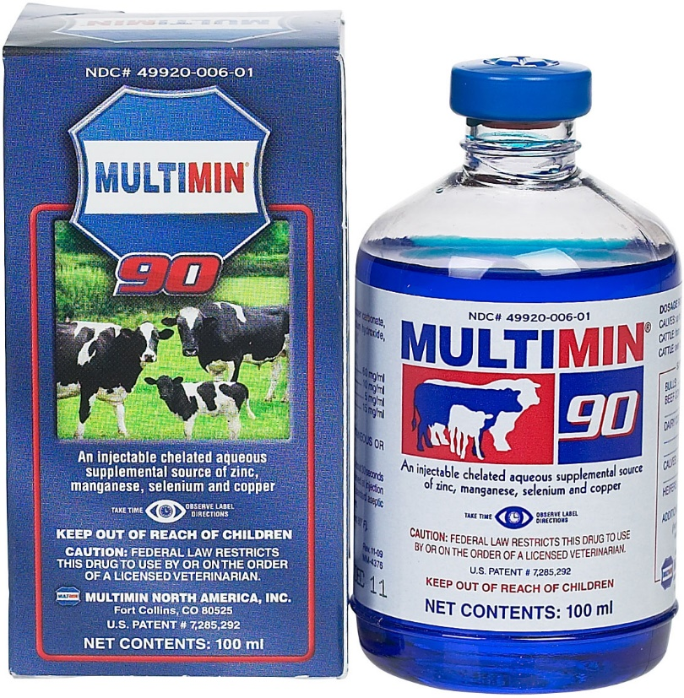
Picture 1 – Multimin 90 ("MultiMin 90 for Cattle Multimin ( - Livestock Pharmacy (Rx) - Vitamins (Rx))," 2016)
Benefits to Canada and its Economy
Exporting anything to another country from Canada boosts the Canadian economy, it provides an extra cash flow for a business. Has the ability to create extra jobs within Canada and other countries, it can boost the economy in Nepal, by farmers having a better output in their industry and an increase in jobs in the transportation sector. Multimin 90 was a Canadian born product which is now produced in the United States of America. The product is sold through Farmers Pharmacy, the product is distributed out of the Farmers Pharmacy warehouse which is located in Cambridge, Ontario, Canada ("FarmersFarmacy.com:," 2015). If the product was exported to Nepal Farmers Pharmacy would have to increase their production, therefore having to increase the number of jobs, which boosts the economy. Also, if this product was exported to Nepal a new position could become available within the company, it would an international sales rep. This person would sell the product to the farmers of Nepal and insure the collection of money.
Part 2 – Exportation to Nepal
Background on Nepal
Nepal is a third-world country located in southeast Asia, which thrives off agricultural, the harvesting of crops and the raising of livestock is the true roots of Nepal. Since Nepal has close to seven million members of the cattle family in the country therefore their health should be one of the most important things.
Category | Numbers (Million)
Cattle | 7.25
Buffaloes | 5.13
Goat | 9.52
Table 1 – Number of Livestock in Nepal (Chapagain, 2016)

An exportable product out of Canada to help the overall health of cattle in the livestock industry is a vitamin and mineral supplement. This vitamin and mineral supplement is called Multimin 90 and aids in the growth and serves to better the immune system in dairy and beef cattle. Nepal is a country that is stuck in the middle of China and India, it is approximately 147 141 square kilometers, with a population of 28 million. The province of Ontario is seven times larger than the country of Nepal, the country of Canada has a total population of 34 million which is located on 9,984,670 square kilometers (Chapagain, 2016).
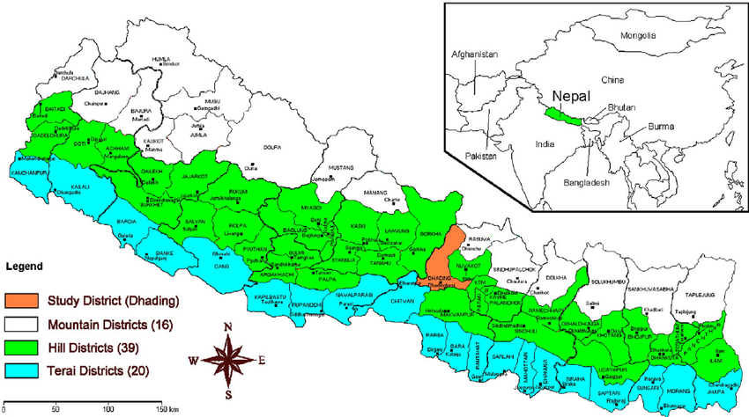
Picture 2- Map of Nepal ("Atlas: Nepal," 2016)

Nepal and Canada aren’t very relative in size or population, the two countries are very different. Of the very few similarities Canada and Nepal share on they do share is number of cattle, well Nepal has approximately 7 million head of cattle Canada has approximately 12.5 million head of cattle, which is part of both the beef and dairy industries ("Interesting Facts About Canada :: Canada Facts," 2011). There are many other differences between the country of Nepal and the country of Canada, such that the people of Nepal make 95% less money, 6.5 times more likely to be unemployed, spend 99% less money in healthcare where this is no insurance, but in contrast have double the number of children on average. Of Nepal’s land, 28% of it is used in the agricultural sector, for having greater than 70% of all the countries employment one would think there would be more land used in the sector, but there is a very wide variety of land types in the country (Chapagain, 2016). There are three types of agrological land regions in Nepal, they are mountain which makes up for 35%, hills at 42%, and terai at 23%. Both the hills and the mountain regions are where the most of the livestock farming occurs, the terai region is where Nepal produces large amounts of small grains (Chapagain, 2016). Of the different agrological regions in Nepal each comes with its own farming system. The mountain farming system mainly consists of all mountains and is not easily accessible via road. For the livestock grown in this area they must be able to travel throughout the mountain terrain for feed purposes and in the winter, they must travel to lower areas for shelter. 28% of the land in the mountain region is irrigated therefore the cattle will have grass to graze on, considering most of the land is rocky and sandy, with small stones (Chapagain, 2016). The hill farming system is very similar to the mountain farming system, but consists of primarily a settlement of the Hindu culture, who’s main cultural animal is the cow. The hill farming has very clay and sandy region that is also 29% irrigated, meaning there will be areas for grazing for cattle. This region is very high for vegetable farming and cash crop farming. There is large amounts land mass for grazing and forest for cattle, buffalo, and goats. Most of the cattle in this region are dairy cattle, used to support the countries milk system (Chapagain, 2016). There is one last farming region in Nepal, it is called the terai farming system, which is primarily and crop based area, considering that 57% of the land in that farming system is irrigated. Many tropical fruits and fresh vegetables are grown in this region. There is very little area for grazing in the terai farming region, therefore any cattle grown and raised in the region must be fed on crop residue, in stall feeding arrangements (Chapagain, 2016).
Transportation
Multimin 90 is a very small product that can be easily transported to Nepal, but as transporting anything across the world it will come with a very high cost. There is many options to ship Multimin 90 across the world, such as the Nepal Shipping Company, DHL, the Mediterranean Shipping Company. But the best option would be Fed Ex, this is due to the fact that Multimin 90 is a very small product, it has a weight of approximately 100 grams per bottle, that is the reason Fed Ex would be the best method for transportation (Gadberry & Simon, 2012). Transportation would consist of planes and transport trucks. Starting with automobiles, the product would be shipped out of the Farmers Pharmacy warehouse in Cambridge, Ontario using a truck, to Pearson international airport. Fed Ex ships out of Pearson international airport, which will take the box of Multimin 90 to the FedEx World Service Center which is located in Nagpur, India ("Locator," 2016). When in India, FedEx will directly take the package to the capital of Nepal, to the FedEx central development region, in Kathmandu via transport truck ("Locator," 2016).
Benefits to Nepal
Nepal is a country with a very high population of cattle, therefore if diseases start they can spread quickly, especially for cattle that are in a venerable state, such as caving, dry-off, etc. That can change with the use of Multimin 90, it can also help cattle at a young age. Especially in the regions of extended grazing periods, where the trace mineral in Multimin 90 are not located in grasses that cattle graze on. Therefore, health will be improved overall, and allowing the animal to grow more. A study was done on young beef cattle aged 100 days to 200 days. 24 beef cattle at 100 days of age were administered the correct dosage of Multimin 90 for their weight and 24 beef cattle the same age were administered nothing. The 24 beef cattle that were administered the Multimin 90 had a higher average of trace minerals found in their blood 100 days later. This study proves that Multimin 90 is a reliable product and can help any animal at any age (Arthington, Moriel, Martins, Lamb, & Havenga, 2014).
Selling Strategy
As a plan to promote the people of Nepal to engage in the use of Multimin 90 it would be best to send a international sales rep over to Nepal with sample doses of Multimin 90 for animals. The sales rep would first do a in depth seminar explaining to the people of Nepal that Multimin 90 would be a good choice for their cattle heard. After the seminar, the international sales rep would go to any willing farms to talk further about the product to the farmers and if the farmer wants the international sales rep would administer sample doses of Multimin 90 to the farmer’s cattle. The international sales rep would visit the country approximately every 2 months, to talk to the farmers to see if the sample doses pleased them, if they did a deal could form with the farmers. Possibly allowing for bottles of Multimin 90 to be shipped across the world for many years to come.
Cost Analysis
The average cost of one 100 milliliter bottle of Multimin 90 is $50 Canadian ("FarmersFarmacy.com:," 2015), which translates to approximately 4100.51 Nepalese Rupees. The cost is very high for famers in Nepal, which have a rather low income, this is evident by the fact that only 7.9% of all employees within the Nepal agriculture sector are hired, the remaining 92.1% is family or unpaid help (Abdulai & Remgi, 1999). The income for the average person in Nepal is 95% less than the average Canadian. The Nepalese make approximately $656 USD, which is 72154.75 Nepalese Rupees. If one Nepalese farmer buys a bottle of Multimin 90 it will be approximately 5.6% of their yearly salary. That price has not included shipping which will cause the price to rise. The cost of shipping ten bottles of Multimin 90 to the capital of Nepal will cost $145.07 USD, which is 15956.54 Nepalese Rupees. Since there is ten bottles of Multimin 90 shipped at once the price of shipping would be divided by ten, costing 1595.65 Nepalese Rupees per bottle. Including shipping the price of one bottle of Multimin 90 bottle would cost 7.9% of the average salary of a Nepalese farmer. If there is a group of farmers in Nepal who all decide to invest in Multimin 90 there will be discounts of shipping, because then another company such as the Nepal shipping company could be used, who specializes in shipping materials in bulk. The Canadian offers a loan program, which the Nepalese farmers could pay back over the course of ten years, as the product takes full affect on their heard, which is after 4 months of use, they could pay back their loan.
Competition
Multimin 90 is a very unique product, there isn’t many other products that are similar to Multimin 90. The only products that are similar to Multimin 90 are oral vitamin/mineral supplements, not injectable ones. Also, any supplements like this will only be made in North America so there is no competition for shipping costs. The only competition lies in oral products such as calcium boluses, or similar products, which do not consist of all four trace minerals (Kjems, 1995). Multmin 90 is the only product of its class created in the world, therefore it has high potential to be successful all over the world.
Conclusion
With one bottle of Multimin 90 serving such a large number of cattle, it can be economically feasible for a farmer that is very well off, but there are many drawbacks with administering the product itself. Since a large majority of the cattle in Nepal are cattle that graze on large open pastures it will be hard to needle every animal with Multimin 90 since they will be running away and be not cooperative. The Nepalese cattle are not very domesticated, meaning they are not too friendly with humans and administering a needle would be very challenging. Another challenge for Nepal farmers would be administering needles, the farmers would need to be taught how to properly administer needles, also, it costs money to use needles, therefore there is extra costs. Overall, this product is not the best for the average Nepal cattle farmer. The input cost for the product is greater than the output cost of Multimin 90. There is no better alternative to Multimin 90 considering it is a very unique product, but overall the cost is too much for Nepal farmers, with a very low income.

References
Abdulai, A., & Remgi, P. P. (1999, December 29). Estimating labor supply of farm households under nonseparability: empirical evidence from Nepal. Retrieved from http://onlinelibrary.wiley.com/doi/10.1111/j.1574-0862.2000.tb00077.x/epdf
Arthington, J. D., Moriel, P., Martins, M. A., Lamb, G. C., & Havenga, L. J. (2014, November 21). Effects of trace mineral injections on measures of performance and trace mineral status of pre- and postweaned beef calves. Retrieved from https://dl.sciencesocieties.org/publications/jas/abstracts/92/6/2630
Atlas: Nepal. (2016). Retrieved from http://www.infoplease.com/atlas/country/nepal.html
Chapagain, T. (2016, September 15). Agriculture and Agri-food Systems in Nepal [PowerPoint slides ]. Retrieved from https://courselink.uoguelph.ca/d2l/le/content/443268/viewContent/1445125/View
Cheema, R. S., Bansal, A. K., & Bilaspuri, G. S. (2009). Manganese Provides Antioxidant Protection for Sperm Cryopreservation that May Offer New Consideration for Clinical Fertility. Retrieved from https://www.hindawi.com/journals/omcl/2009/429158/abs/
FarmersFarmacy.com:. (2015). Retrieved from http://www.farmersfarmacy.com/gc/gc_page
FedEx: Shipping, Logistics Management and Supply Chain Management. (2016). Retrieved from https://www.fedex.com/ratefinder/standalone?method=getQuickQuote
Fell, B. F., Dinsdale, D., & Mills, C. F. (1975). Changes in enterocyte mitochondria associated with deficiency of copper in cattle. - Abstract - Europe PMC. Retrieved from http://europepmc.org/abstract/med/167409
Gadberry, M. S., & Simon, K. (2012). Response of beef calves, not exposed to free choice mineral supplements, to an injectable trace mineral supplement. Retrieved from http://arkansasagnews.uark.edu/606-4.pdf
Interesting Facts About Canada :: Canada Facts. (2011). Retrieved from http://www.canadafacts.org/
Kjems, G. (1995, February 28). Patent US5393535 - Orally administerable calcium supplement for cattle - Google Patents. Retrieved from https://www.google.com/patents/US5393535
Locator. (2016). Retrieved from http://www.fedex.com/locate/?locale=en_ca
Miller, M. A., & Thompson, J. R. (2015, January 9). "Selenium Deficiency in Cattle" by Marc A. Miller and James R. Thompson. Retrieved from http://lib.dr.iastate.edu/iowastate_veterinarian/vol45/iss2/3/
Miller, W. J. (1970, August). Zinc Nutrition of Cattle: A Review1. Retrieved from http://www.sciencedirect.com/science/article/pii/S002203027086355X
MultiMin 90 for Cattle Multimin ( - Livestock Pharmacy (Rx) - Vitamins (Rx)). (2016). Retrieved from https://www.valleyvet.com/ct_detail.html?pgguid=4851cb54-8fd7-4a84-95c9-7814148970d7
Pogge, D. J., Ritcher, E. L., Drewnoski, M. E., & Hansen, S. L. (2012). Abstract | Digital Library. Retrieved from https://dl.sciencesocieties.org/publications/jas/abstracts/90/8/2692
The Cattleman. (2010, April). Improved Multimin® 90 Replaces Multimin® 70. Retrieved from http://search.proquest.com.subzero.lib.uoguelph.ca/docview/203141909?rfr_id=info%3Axri%2Fsid%3Aprimo

